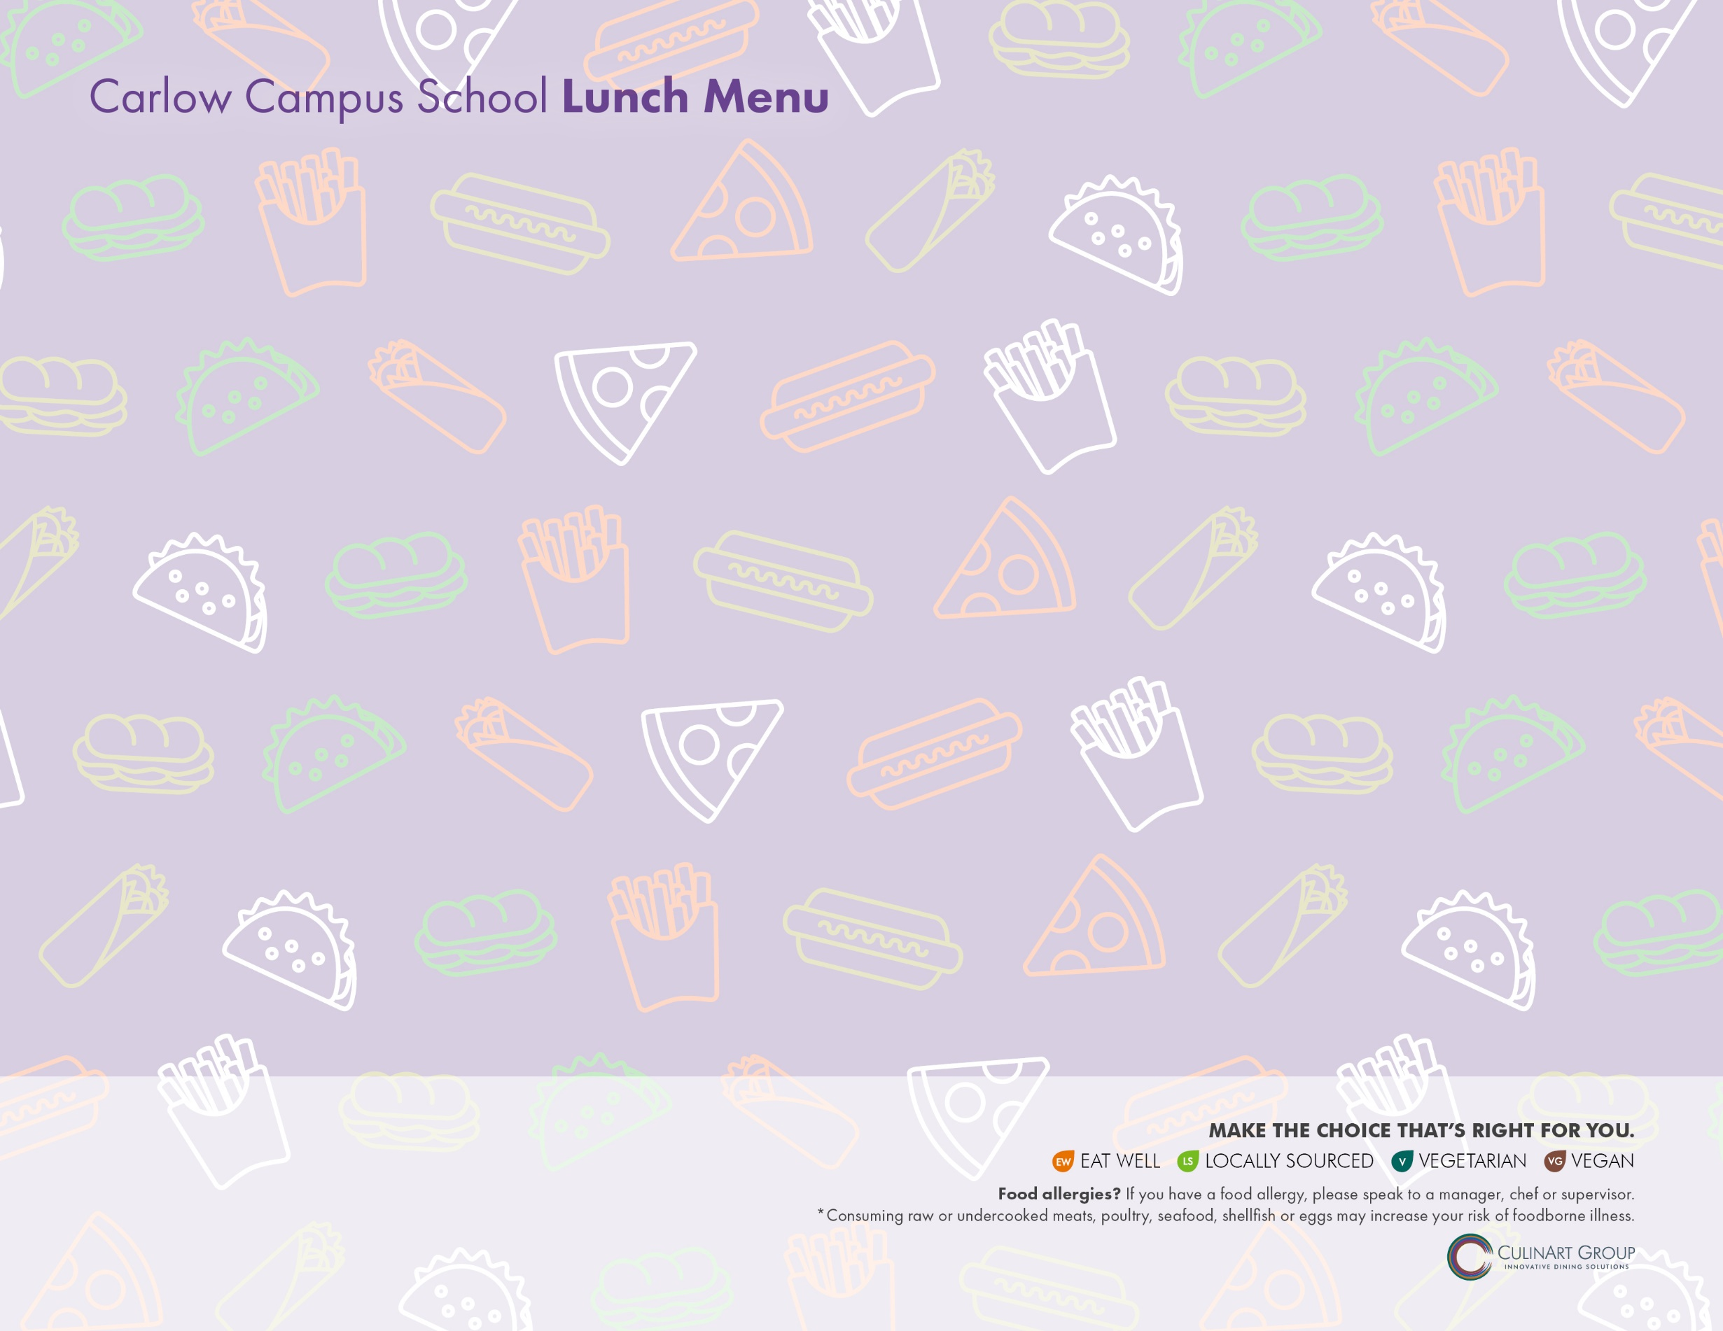**May 2021**

|  |  |  |  |  |
| --- | --- | --- | --- | --- |
| **MONDAY** | **TUESDAY** | **WEDNESDAY** | **THURSDAY** | **FRIDAY** |
| **3** Ham & Cheddar on Spinach Wrap  **OR**  Chicken Tenders & French Fries  Carrots, Celery, Tomatoes with Ranch  *Rotating Side: Fresh Mixed Fruit/ Jell-O/ Pudding* | **4 TACO TUESDAY**  Mexican Taco Snack Wrap  Fiesta Power Pack – Corn Chips, Pepper Jack Cheese Cubes, Guacamole, Salsa  *Rotating Side: Fresh Mixed Fruit/ Jell-O/ Pudding* | **5** Cucumber Hummus Wrap  Celery & Carrots with Cucumber  & Yogurt Dip  *Rotating Side: Fresh Mixed Fruit/ Jell-O/ Pudding* | **6** Chicken Tenders & French Fries  **OR**  Grilled Cheese & Turkey on Whole Grain  Veggie Sticks & Roasted Garlic Hummus  *Rotating Side: Fresh Mixed Fruit/ Jell-O/ Pudding* | **7 PIZZERIA DAY**  Cheese Pizza Bagel  Pepperoni Pizza Bagel  Garden Side Salad  *Rotating Side: Fresh Mixed Fruit/ Jell-O/ Pudding* |
| **10** Turkey Whole Wheat Wrap  **OR**  Chicken Tenders & French Fries  Carrots, Celery, Tomatoes with Ranch  *Rotating Side: Fresh Mixed Fruit/ Jell-O/ Pudding* | **11 TACO TUESDAY**  Tex Mex Taco Pocket  Fiesta Power Pack – Corn Chips, Pepper Jack Cheese Cubes, Guacamole, Salsa  *Rotating Side: Fresh Mixed Fruit/ Jell-O/ Pudding* | **12** Tuscan Bistro Pepperoni Pinwheel  Celery & Carrots with Cucumber  & Yogurt Dip  *Rotating Side: Fresh Mixed Fruit/ Jell-O/ Pudding* | **13** Chicken Tenders & French Fries  **OR**  Buffalo Chicken Hoagie  Veggie Sticks & Roasted Garlic Hummus  *Rotating Side: Fresh Mixed Fruit/ Jell-O/ Pudding* | **14 PIZZERIA DAY**  Cheese Pizza Bagel  Pepperoni Pizza Bagel  Garden Side Salad  *Rotating Side: Fresh Mixed Fruit/ Jell-O/ Pudding* |
| **17** Cheeseburger Snack Wrap  **OR**  Chicken Tenders & French Fries  Carrots, Celery, Tomatoes with Ranch  *Rotating Side: Fresh Mixed Fruit/ Jell-O/ Pudding* | **18 TACO TUESDAY**  Mexican Taco Snack Wrap  Fiesta Power Pack – Corn Chips, Pepper Jack Cheese Cubes, Guacamole, Salsa  *Rotating Side: Fresh Mixed Fruit/ Jell-O/ Pudding* | **19**  BBQ Veggie Hoagie  with Avocado & Cheese  Celery & Carrots with Cucumber & Yogurt Dip  *Rotating Side: Fresh Mixed Fruit/ Jell-O/ Pudding* | **20** Chicken Tenders & French Fries  **OR**  Roast Beef Sandwich  Veggie Sticks & Roasted Garlic Hummus  *Rotating Side: Fresh Mixed Fruit/ Jell-O/ Pudding* | **21 PIZZERIA DAY**  Cheese Pizza Bagel  Pepperoni Pizza Bagel  Garden Side Salad  *Rotating Side: Fresh Mixed Fruit/ Jell-O/ Pudding* |
| **24** BBQ Chicken Snack Wrap  **OR**  Chicken Tenders & French Fries  Carrots, Celery, Tomatoes with Ranch  *Rotating Side: Fresh Mixed Fruit/ Jell-O/ Pudding* | **25 TACO TUESDAY**  Taco Salad Wrap  Fiesta Power Pack – Corn Chips, Pepper Jack Cheese Cubes, Guacamole, Salsa  *Rotating Side: Fresh Mixed Fruit/ Jell-O/ Pudding* | **26** Peanut Butter & Jelly on Wheat  Celery & Carrots with Cucumber & Yogurt Dip  *Rotating Side: Fresh Mixed Fruit/ Jell-O/ Pudding* | **27** Chicken Tenders & French Fries  **OR**  Black Bean Burger on Whole Wheat Bun  Veggie Sticks & Roasted Garlic Hummus  *Rotating Side: Fresh Mixed Fruit/ Jell-O/ Pudding* | **28 PIZZERIA DAY**  Cheese Pizza Bagel  Pepperoni Pizza Bagel  Garden Side Salad  *Rotating Side: Fresh Mixed Fruit/ Jell-O/ Pudding* |
| **31** Closed |  |  |  |  |

**ALTERNATE MEAL OPTION** Buttered Pasta

**CHOICE OF MILK** 2% White, 1% Chocolate, Strawberry, Skim or Lactaid

**CHOICE OF JUICE** Apple, Cranberry or Orange